Lab Exercise 3– Terraform IAM User Setting
Prerequisites: Terraform Installed: Make sure you have Terraform installed on your machine. Follow the official installation guide if needed.
AWS Credentials: Ensure you have AWS credentials (Access Key ID and Secret Access Key) configured. You can set them up using the AWS CLI or by setting environment variables.
Exercise Steps:
Step 1: Create a New Directory:
Create a new directory for your Terraform configuration:
“Terraform-Demo”
O/P:
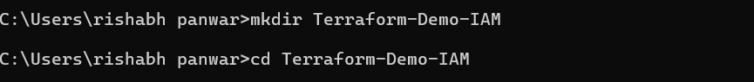
Step 2: Create Terraform Configuration File (main.tf):
Create a file named main.tf with the following content:
terraform {
required_providers {
aws = {
source = "hashicorp/aws"
version = "5.31.0"
}
}
}

provider "aws" {
region = "ap-south-1"
access_key = "your IAM access key"
secret_key = "your secret access key"
}

This script defines an AWS provider and provisions an EC2 instance.
Step 3: Initialize Terraform:
Run the following command to initialize your Terraform working directory:
O/p:
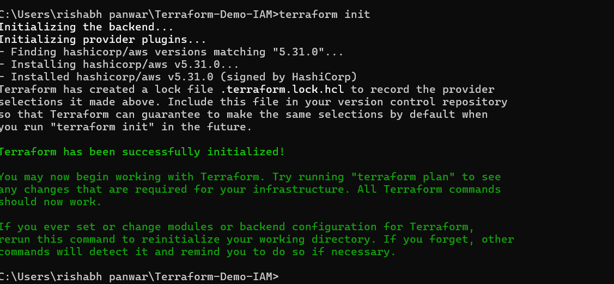
terraform init

